

B2B Assets Migration from 5.5 to 5.7.0.0

Steps to Migration of Code

Document History

|  |  |  |  |
| --- | --- | --- | --- |
| Version | Updated By | Date (dd/mm/yyyy) | Comments |
| 1.0 | Venkatesh Dasari | 08/12/2015 | Initial Draft |
| 1.0 | Kinnari Pandam | 08/12/2015 | Initial Draft |
| 1.0 | Namrata Kapaleshwari | 04/12/2015 | Initial Draft |

Document Sign-Off

|  |  |  |
| --- | --- | --- |
| Name | Role | Signature/Date |
| Deepali Rathore |  |  |
| Gyaneshwar Dubey |  |  |
|  |  |  |

Table of Contents

1. Introduction 4

1.1 Purpose 4

1.2 Intended Audience 4

1.3 Document Scope 4

1.4 Pre-requisite 4

1.5 Assumptions/Restrictions 4

1.6 Documents Structure 4

2. Installation and Configuration 5

2.1 Installation steps of hybris 5.7.0.0 5

2.2 Configuration Steps for B2BAssets (Powertools) Store Up 6

2.2.1 Changes in b2bassetscore 7

2.2.2 Changes in b2bassetsinitialdata 9

3. Addons Configuration 11

3.1 Multicarts 11

3.1.1 Installation steps for Multicarts addon 11

3.1.2 Configuration steps for the Multicarts addon 12

3.2 OrderSearch 14

3.2.1 Installation steps for OrderSearch addon 14

3.2.2 Configuration steps for the OrderSearch addon 15

3.3 ProductSearch 20

3.3.1 Installation steps for ProductSearch addon 20

3.3.2 Configuration steps for the ProductSearch addon 21

3.4 QuickOrder 24

3.4.1 Installation steps for QuickOrder addon 24

3.5 SingleViewOrders 26

3.5.1 Installation steps for SingleViewOrders addon 26

3.5.2 Configuration steps for the SingleViewOrders addon 27

3.6 InterfaceError 29

3.6.1 Installation steps for InterfaceError addon 29

3.7 SolrSearchRestriction 29

3.7.1 Installation steps for SolrSearchRestriction addon 29

3.7.2 Configuration steps for the SolrSearchRestriction addon 30

3.8 HotFolder 31

3.8.1 Installation steps for Hotfolder addon 31

3.8.2 Configuration steps for the HotFolder addon 32

4. Responsive UI & Migration 34

4.1 Creating Template For UI In v5.7 35

4.2 Changing Theme For B2BAssets 37

4.3 To Make Pages & Components Responsive: 38

4.4 Modify Template Pages 38

4.5 Modify JSP & Tag Files 39

4.5.1 Example 39

5. B2BAssets Responsive UI Designs 42

6. UI Changes In v5.7 45

6.1 Newly Applied UI Changes For B2BAssets v5.7 45

6.2 Resolved Extra Space Issue 62

6.3 Checkout UI Difference In v5.7 63

1. Introduction

Purpose

This document is the Technical Design Document which provides information on steps to Migration B2BAssets with addons and responsive UI from 5.5.1.1 to 5.7.0.0.

Intended Audience

This document is aimed at Hybris developers and technical members who want to upgrade B2Bassets with addons and responsive UI from 5.5.1.1 to 5.7.0.0 in hybris.

Document Scope

This document covers the details about the steps and change in code, ImpEx, UI changes like CSS, JSPs, JS, jQuery to make it responsive.

Pre-requisite

* Eclipse setup of B2Bassets 5.7 version
* Setup files of previous version i.e. v5.5.1.1 B2Bassets

Assumptions/Restrictions

B2BAssets available for hybris version 5.5.1.1.

Hybris 5.5.1.1 custom code and UI will be migrated to 5.7.0.0 but this doesn’t support data migration. Only core functionality and UI will be available in 5.7.0.0

Documents Structure

|  |  |  |
| --- | --- | --- |
| Section | | Description |
| 1 | Introduction | Describes the purpose and intended audience of the document and explains its structure. |
| 2 | Installation & Configuration | Steps to install and configure the core modules. |
| 3 | Addons Configuration | Steps to install and configure the addons/assests. |
| 4 | Responsive UI changes | Step wise description to make the responsive UI. |

1. Installation and Configuration

Installation steps of hybris 5.7.0.0

1. Download and unzip the **hybris-commerce-suite-5.7.0.0.zip** from hybris wiki.
2. Navigate to the ${HYBRIS_BIN_DIR}/**platform** directory, set ant environment by entering the following command:

* On Windows: **setantenv**.bat
* On Linux or Mac: **. ./setantenv.sh**

1. Run the ant **modulegen** command and adjust the input.name and input.package parameters, as follows:

|  |
| --- |
| ant modulegen -Dinput.module=accelerator -Dinput.name= b2bassets -Dinput.package= com.capgemini.b2bassets -Dinput.template=develop |

* 1. For b2bassets (**Powertools**) store up refer point no. **2.2** and find the file changes.

1. Open the {HYBRIS_HOME}/installer/recipes/**b2b_acc_plus/build.gradle** file with a text editor
2. Replace all occurrences of **yaccelerator** with **b2bassests** and save the file.
3. Also add some properties in {HYBRIS_HOME}/installer/recipes/**b2b_acc_plus/build.gradle** file

* MySql related Properties :
* property 'db.url', 'jdbc:mysql://localhost/hybris57'
* property 'db.driver', 'com.mysql.jdbc.Driver'
* property 'db.username', 'root'
* property 'db.password', 'root'
* Addons related properties :
* property 'b2bassetsstorefront.additionalWebSpringConfigs.b2bacceleratoraddon', 'classpath:/b2bacceleratoraddon/web/spring/b2bacceleratoraddon-web-spring.xml,classpath:/b2bacceleratoraddon/web/spring/multi-step-checkout-config.xml,classpath:/b2bacceleratoraddon/web/spring/b2bacceleratoraddon-spring-security-config.xml'
* property 'b2bassetsstorefront.additionalWebSpringConfigs.assistedservicestorefront', 'classpath:/assistedservicestorefront/web/spring/assistedservicestorefront-web-spring.xml'
* b2bassetsstorefront.additionalWebSpringConfigs.commerceorgaddon=classpath:/commerceorgaddon/web/spring/commerceorgaddon-web-spring.xml,classpath:/commerceorgaddon/web/spring/commerceorgaddon-spring-security-config.xml
* Addons installation extensions :

|  |
| --- |
| ant modulegen -Dinput.module=accelerator -Dinput.name= b2bassets -Dinput.package= com.capgemini.b2bassets -Dinput.template=develop |

1. Navigate to the **{HYBRIS_HOME}/installer** directory. Invoke the Installer with the b2b_acc_plus recipe by entering the following command:

* On Windows: **install.bat -r b2b_acc_plus**
* On Linuxor Mac **:** **./install.sh -r b2b_acc_plus**

1. Initialize system using any of the below step
   1. **ant initialize** command

|  |
| --- |
| ant initialize -Dtenant=master |

* 1. **If** the hybris server is up, you can select **Initialization** in the **Platform** tab of the hybris Administration Console (**hAC**).
  2. Navigate to the {HYBRIS_HOME}/installer directory.
* On Windows: **install.bat -r b2b_acc_plus initialize**
* On Linuxor Mac **:** **./install.sh -r b2b_acc_plus initialize**

Configuration Steps for B2BAssets (Powertools) Store Up

After running ant **modulegen** command following extensions will be generated:

* b2bassetscockpits
* b2bassetscore
* b2bassetsfacades
* b2bassetsfulfilmentprocess
* b2bassetsinitialdata
* b2bassetsstorefront
* b2bassetstest

Changes in b2bassetscore

1. Solr field value providers added in b2bassetscore-spring.xml

|  |
| --- |
| b2bassetscore/resources/b2bassetscore-spring.xml |
| <bean id="powertoolsCategoryCodeValueProvider" parent="abstractCategoryCodeValueProvider">  <property name="categorySource" ref="powertoolsCategorySource"/>  </bean>  <bean id="powertoolsBrandCategoryCodeValueProvider" parent="abstractCategoryCodeValueProvider">  <property name="categorySource" ref="powertoolsBrandCategorySource"/>  </bean>  <bean id="powertoolsVariantCategoryCodeValueProvider" parent="abstractCategoryCodeValueProvider">  <property name="categorySource" ref="powertoolsVariantCategorySource"/>  </bean>  <bean id="powertoolsCategoryNameValueProvider" parent="abstractCategoryNameValueProvider">  <property name="categorySource" ref="powertoolsCategorySource"/>  </bean>    <bean id="powertoolsBrandCategoryNameValueProvider" parent="abstractCategoryNameValueProvider">  <property name="categorySource" ref="powertoolsBrandCategorySource"/>  </bean>    <bean id="powertoolsCategorySource" parent="variantCategorySource">  <property name="rootCategory" value="1"/> <!-- '1' is the root icecat category -->  </bean>  <bean id="powertoolsVariantCategorySource" parent="variantCategorySource"/>  <bean id="powertoolsBrandCategorySource" parent="defaultCategorySource">  <property name="rootCategory" value="brands"/> <!-- 'brands' is the root of the brands hierarchy -->  </bean> |

1. Added b2b-budget, b2bcostcenter, b2bcredit-limit and all related changes made hybris\bin\custom\b2bassets\b2bassetscore\resources\b2bassetscore\import\common\**user-groups.impex**



1. New theme added in **themes**.impex:

 

1. Added New item type for Account Page:

|  |
| --- |
| b2bassetscore/resources/b2bassetscore-items.xml |
| <itemtype code="AccountSideNavigationComponent" autocreate="true"  generate="true" extends="SimpleCMSComponent" jaloclass="com.capgemini.b2bassets.core.jalo.components.AccountSideNavigationComponent">  <description>It represents account navigation bar component that contains cms navigation node.</description>  <attributes>  <attribute qualifier="title" type="localized:java.lang.String">  <persistence type="property" />  <modifiers />  <description>Localized title of the component.</description>  </attribute>  <attribute type="java.lang.String" qualifier="styleClass">  <persistence type="property" />  <modifiers />  <description>CSS style class of this bar component.</description>  </attribute>  <attribute type="CMSNavigationNode" qualifier="navigationNode">  <persistence type="property" />  <modifiers />  <description>The cms navigation node of this navigation component.</description>  </attribute>  </attributes>  </itemtype> |

1. Modified **CoreSystemSetup**.java to import our store data when the server is initialized or updated.

(path:hybris\bin\custom\b2bassets\b2bassetscore\src\com\capgemini\b2bassets\core\setup\CoreSystemSetup.java)



Changes in b2bassetsinitialdata

1. One of the goals of the initialization process is to prepare the data for your store.

- The accelerator provides two dedicated initialization hooks that allow you to import your custom data.

1. core data hook - in our namespace that is the CoreSystemSetup class in b2bassetscore extension.
2. sample data hook - in our namespace that is the InitialDataSystemSetup class in b2bassetsinitialdata extension.
3. Modified InitialDataSystemSetup.java to import our store data when the server is initialized or updated and the b2bassetscore project data checkbox is selected. (path:hybris\bin\custom\b2bassets\b2bassetsinitialdata\src\com\capgemini\b2bassets\initialdata\setup\InitialDataSystemSetup.java file)



1. Navigate to: hybris\bin\custom\b2bassets\b2bassetsinitialdata\resources\b2bassetsinitialdata\import

Here, the two folders named as coredata and sampledata which contains basic store data, content catalog, product catalog, users, etc.

Rename the project folders

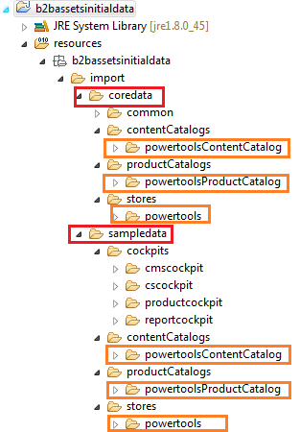

-Modified all the required files in coredata and sampledata folders, build the code base and restart the hybris server.

-Go to the system [update](http://localhost:9001/platform/update) panel in the admin console.

-To import our project data, you need to tick two checkboxes in the project data section (b2bassetscore and b2bassetsinitialdata).

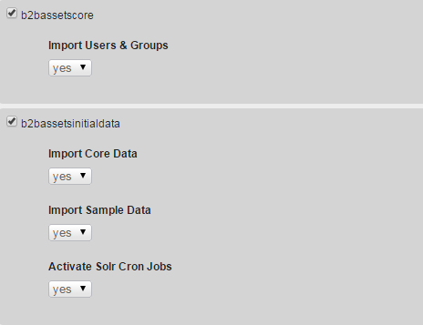

Once you have imported the data, you can go to the [hMC](http://localhost:9001/hmc/hybris)and look in the Base Commerce section that we have a new store called 'powertools' and it has a website assigned with the same name.

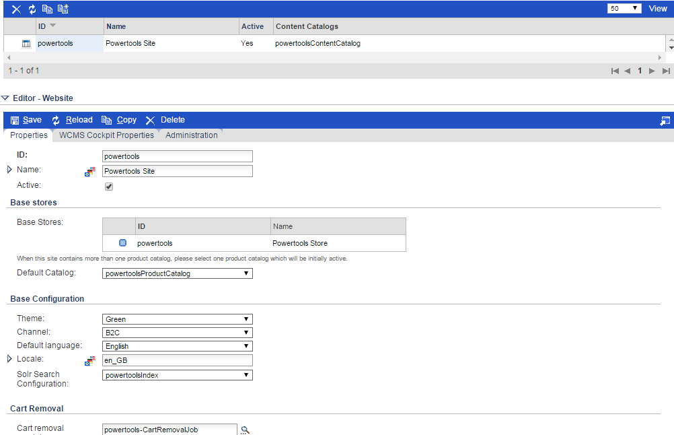

1. Addons Configuration

Multicarts

Installation steps for Multicarts addon

1. Add the multicarts extension in **build.gradle** file (installer\recipes\b2b_acc_plus\build.gradle)

|  |
| --- |
| extensions {  …  extName 'multicarts'  … } |

1. Add multicarts extension in addons list in **build.gradle** file.

|  |
| --- |
| pl.project.addons {  names "liveeditaddon,b2bacceleratoraddon,commerceorgaddon,accountsummaryaddon,assistedservicestorefront,captchaaddon,**multicarts** "  template "b2bassetsstorefront"  storeFronts "b2bassetsstorefront"  platform pl  } |

1. Add following line in **build.gradle** file.

|  |
| --- |
| localProperties {  ...  property 'b2bassetsstorefront.additionalWebSpringConfigs.multicarts','classpath:/multicarts/web/spring/multicarts-web-spring.xml'  ...} |

1. Navigate to the **{HYBRIS_HOME}**/installer directory. Invoke the Installer with the b2b_acc recipe by entering the following command:

On Windows: **install.bat -r b2b_acc_plus**

On Linuxor Mac**:** **./install.sh -r b2b_acc_plus**

1. The install script creates a new **localextensions.xml** file using the newly created **multicarts** extension, and also installs the required B2B AddOns into the new **b2bassetsstorefront** extension.

|  |
| --- |
| config/ **localextensions.xml** |
| <extensions>  …  <extension name='multicarts' />  …  </extensions> |

1. Copy multicarts module directory into **hybris/bin/custom** folder.
2. Replace yb2bacceleratorstorefront with **b2bassetsstorefront** in **project.properties.template** file (hybris\bin\custom\multicarts\project.properties.template). Run addon install command.

|  |
| --- |
| b2bassetsstorefront.additionalWebSpringConfigs.multicarts=classpath:/multicarts/web/spring/multicarts-web-spring.xml |

1. Run addon install command:

Navigate to the **{HYBRIS_HOME}**/bin/platform directory and run following command-

|  |
| --- |
| ant addoninstall -Daddonnames="multicarts" -DaddonStorefront.b2bassetsstorefront="b2bassetsstorefront" |

1. Navigate to the **{HYBRIS_HOME}**/bin/platform directory and build the server : **ant clean all**

Configuration steps for the Multicarts addon

**Build Errors and Solution:**

1. You will get following multicart error after first build.

|  |
| --- |
| **Error :**  [ycheckdeployments] No deployment defined for non-abstract itemType CartFollower in file: D:\B2BAssets\Migration5.7.0.0\hybris-commerce-suite-5.7.0.0\hybris\bin\custom\multicarts/resources/multicarts-items.xml  [ycheckdeployments] No deployment defined for non-abstract itemType CartShare in file: D:\B2BAssets\Migration5.7.0.0\hybris-commerce-suite-5.7.0.0\hybris\bin\custom\multicarts/resources/multicarts-items.xml |

1. Add deployment tag in multicarts-items.xml as:

|  |
| --- |
| **Solution:**  <itemtype code=*"CartFollower"* generate=*"true"* autocreate=*"true"*>  <!--Deepali: added for 5.7.0.0 migration -->  <deployment table=*"CartFollower_deployment"* typecode=*"32602"*/>  <!-- ends -->  <attributes>  <attribute qualifier=*"notification"* type=*"java.lang.Boolean"* generate=*"true"*>  <persistence type=*"property"*/>  <modifiers read=*"true"* write=*"true"* initial=*"true"*/>  <defaultvalue>false</defaultvalue>  </attribute>  </attributes>  </itemtype>  <itemtype code=*"CartShare"* generate=*"true"* autocreate=*"true"*>  <!--Deepali: added for 5.7.0.0 migration -->  <deployment table=*"CartShare_deployment"* typecode=*"32603"*/>  <!-- ends -->  </itemtype> |

1. Now again build the server : **ant clean all**

**Populating MultiCarts link in My Account left hand navigation:**

1. Add following at end in \hybris\bin\custom\b2bassets\b2bassetsinitialdata\resources\b2bassetsinitialdata\import\sampledata\contentCatalogs\powertoolsContentCatalog\**cms-content.impex**

|  |
| --- |
| # CMS Link Component  INSERT_UPDATE CMSLinkComponent;$contentCV[unique=true];uid[unique=true];name;url;&linkRef;&componentRef;target(code)[default='sameWindow'];$category;$product;  ;;AccountMultiCartsLink;My Carts Link;/multicarts;AccountMultiCartsLink;AccountMultiCartsLink;;;  # CMS Navigation Nodes - My Account  INSERT_UPDATE CMSNavigationNode;uid[unique=true];$contentCV[unique=true];name;parent(uid, $contentCV);links(&linkRef);&nodeRef  ;AccountLeftNavNode;;My Account;SiteRootNode;AccountProfileLink,AccountAddressBookLink,AccountPaymentDetailsLink,AccountMyQuotesLink,AccountOrderHistoryLink,AccountMyReplenishmentOrdersLink,AccountApprovalDashboardLink,AccountMultiCartsLink;AccountLeftNavNode  # CMS User Group Restrictions  INSERT_UPDATE CMSUserGroupRestriction;$contentCV[unique=true];uid[unique=true];name;userGroups(uid);includeSubgroups;components(&componentRef)  ;;MyAccountLinkCustomerGroupRestriction;My Account Link Customer Group Restriction;b2bcustomergroup;true;AccountAddressBookLink,AccountPaymentDetailsLink,AccountMyQuotesLink,AccountOrderHistoryLink,AccountMyReplenishmentOrdersLink,AccountAddressBookNavigationComponent, AccountPaymentDetailsNavigationComponent, AccountMyQuotesNavigationComponent, AccountOrderHistoryNavigationComponent,AccountMultiCartsLink |

1. Now add in language file hybris\bin\custom\b2bassets\b2bassetsinitialdata\resources\b2bassetsinitialdata\import\sampledata\contentCatalogs\powertoolsContentCatalog\**cms-content_en.impex**

[Following impexes, here we are considering only English, if there is any other language then update those too.]

|  |
| --- |
| # CMS Link Components  UPDATE CMSLinkComponent;$contentCV[unique=true];uid[unique=true];linkName[lang=$lang]  ;;AccountMultiCartsLink;"My Carts" |

1. Build the server : **ant clean all**
2. Start the hybris server **hybrisserver.bat** and Update System with selecting multicarts addon.

OrderSearch

Installation steps for OrderSearch addon

1. Add the ordersearch extension in build.gradle file (installer\recipes\b2b_acc_plus\build.gradle)

|  |
| --- |
| extensions {  …  extName 'multicarts'  extName **'ordersearch'**  … } |

1. Add ordersearch extension in addons list in build.gradle file

|  |
| --- |
| pl.project.addons {  names "liveeditaddon,b2bacceleratoraddon,commerceorgaddon,accountsummaryaddon,assistedservicestorefront,captchaaddon,**ordersearch**,multicarts"  template "b2bassetsstorefront"  storeFronts "b2bassetsstorefront"  platform pl  } |

1. Add following line in **build.gradle** file.

|  |
| --- |
| localProperties {  ...  property 'b2bassetsstorefront.additionalWebSpringConfigs.ordersearch','classpath:/ordersearch/web/spring/ordersearch-web-spring.xml'  ...} |

1. Navigate to the **{HYBRIS_HOME}**/installer directory. Invoke the Installer with the b2b_acc recipe by entering the following command:

On Windows: **install.bat -r b2b_acc_plus**

On Linux or Mac**: ./install.sh -r b2b_acc_plus**

1. The install script creates a new **localextensions.xml** file using the newly created **ordersearch** extension, and also installs the required B2B AddOns into the new **b2bassetsstorefront** extension.

|  |
| --- |
| config/ **localextensions.xml** |
| <extensions>  …  <extension name='multicarts' />  <extension name=**'ordersearch'**/>  …  </extensions> |

1. Copy ordersearch module directory into **hybris/bin/custom** folder.
2. Replace yb2bacceleratorstorefront with **b2bassetsstorefront** in **project.properties.template** file (hybris\bin\custom\ordersearch\project.properties.template). Run addon install command.

|  |
| --- |
| b2bassetsstorefront.additionalWebSpringConfigs. ordersearch=classpath:/ordersearch /web/spring/ordersearch-web-spring.xml |

1. Run addon install command:

Navigate to the **{HYBRIS_HOME}**/bin/platform directory and run following command-

|  |
| --- |
| ant addoninstall -Daddonnames="ordersearch " -DaddonStorefront.b2bassetsstorefront="b2bassetsstorefront” |

1. Navigate to the **{HYBRIS_HOME}**/bin/platform directory and build the server : **ant clean all**

Configuration steps for the OrderSearch addon

**Solving Build errors:**

1. You will get following errors after first build.

|  |
| --- |
| Errors:  1. ERROR in D:\hybris_assets\B2Bassets_5.7.0.0\hybris-commerce-suite-5.7.0.0\hybris\bin\custom\b2bassets\b2bassetsstorefront\web\addonsrc\ordersearch\com\generic\ordersearch\controllers\pages\OrderSearchController.java (at line 11)  import com.capgemini.b2bassets.storefront.controllers.pages.AbstractSearchPageController;  The import com.capgemini.b2bassets.storefront.controllers.pages.AbstractSearchPageController cannot be resolved  2. ERROR in D:\hybris_assets\B2Bassets_5.7.0.0\hybris-commerce-suite-5.7.0.0\hybris\bin\custom\b2bassets\b2bassetsstorefront\web\addonsrc\ordersearch\com\generic\ordersearch\controllers\pages\OrderSearchController.java (at line 12)  import com.capgemini.b2bassets.storefront.controllers.pages.AbstractSearchPageController.ShowMode;  The import com.capgemini.b2bassets.storefront.controllers.pages.AbstractSearchPageController cannot be resolved  3. ERROR in D:\hybris_assets\B2Bassets_5.7.0.0\hybris-commerce-suite-5.7.0.0\hybris\bin\custom\b2bassets\b2bassetsstorefront\web\addonsrc\ordersearch\com\generic\ordersearch\controllers\pages\OrderSearchController.java (at line 56)  public class OrderSearchController extends AbstractSearchPageController  4. ERROR in D:\hybris_assets\B2Bassets_5.7.0.0\hybris-commerce-suite-5.7.0.0\hybris\bin\custom\b2bassets\b2bassetsstorefront\web\addonsrc\ordersearch\com\generic\ordersearch\controllers\pages\OrderSearchController.java (at line 83)  final PageableData pageableData = createPageableData(page,getSiteConfigService().getInt("order.search.pageSize", 0), null, ShowMode.Page);  The method getSiteConfigService() is undefined for the type OrderSearchController  5. ERROR in D:\hybris_assets\B2Bassets_5.7.0.0\hybris-commerce-suite-5.7.0.0\hybris\bin\custom\b2bassets\b2bassetsstorefront\web\addonsrc\ordersearch\com\generic\ordersearch\controllers\pages\OrderSearchController.java (at line 83)  final PageableData pageableData = createPageableData(page, getSiteConfigService().getInt("order.search.pageSize", 0), null, ShowMode.Page);  6. ERROR in D:\hybris_assets\B2Bassets_5.7.0.0\hybris-commerce-suite-5.7.0.0\hybris\bin\custom\b2bassets\b2bassetsstorefront\web\addonsrc\ordersearch\com\generic\ordersearch\controllers\pages\OrderSearchController.java (at line 84)  Boolean showCarts = getSiteConfigService().getBoolean("order.search.showcarts", true);  The method getSiteConfigService() is undefined for the type OrderSearchController |

1. In OrderSearchFacetSearchService.java (ordersearch\src\com\generic\ordersearch\service\impl\OrderSearchFacetSearchService.java) Removed @override from checkCatalogVersions() method.

|  |
| --- |
| //@Override //commented for migration errors  **protected** **void** checkCatalogVersions(**final** SearchQuery query) **throws** FacetSearchException  {  // Do nothing  } |

1. In OrderSearchController.java

(ordersearch\acceleratoraddon\web\src\com\generic\ordersearch\controllers\pages\OrderSearchController.java)

|  |
| --- |
| Commented:  //import com.capgemini.b2bassets.storefront.controllers.pages.AbstractSearchPageController;  //import com.capgemini.b2bassets.storefront.controllers.pages.AbstractSearchPageController.ShowMode; |
| Added:  **import** de.hybris.platform.acceleratorstorefrontcommons.controllers.pages.AbstractSearchPageController;  **import** de.hybris.platform.acceleratorstorefrontcommons.controllers.pages.AbstractSearchPageController.ShowMode;  **…**  **public** **class** OrderSearchController **extends** AbstractSearchPageController  {  //Added for migration  **protected** **static** **final** String *PAGINATION_TYPE* = "pagination.type";  **protected** **static** **final** String *PAGINATION* = "pagination";  **protected** **static** **final** String *IS_SHOW_ALLOWED* = "isShowAllAllowed";  ...  } |

1. In ordersearch\project.properties & ordersearch\project.properties.template add following lines:

|  |
| --- |
| b2bassetsstorefront.additionalWebSpringConfigs.ordersearch=classpath:/ordersearch/web/spring/ordersearch-web-spring.xml |

1. In ordersearch-spring.xml (hybris\bin\custom\ordersearch\resources) added property facetSearchService & indexedTypeName in defaultCustomOrderSearchSolrQueryPopulator bean to fix ordersearch issue.

|  |
| --- |
|  |

1. Added B2BAssetsProductSearchSolrQueryPopulator.java for resolving solr index issue while click on category link.

|  |
| --- |
|  |

1. In OrderSearchSolrQueryPopulator.java (hybris\bin\custom\ordersearch\src\com\generic\ordersearch\converters\populator) made changes to fix ordersearch issue.

|  |
| --- |
|  |

1. In OrderSearchController.java (hybris\bin\custom\ordersearch\acceleratoraddon\web\src\com\generic\ordersearch\controllers\pages) changing B2BUnit id by removing space in characters to fix ordersearch issue.

|  |
| --- |
|  |

1. Added file DefaultB2BAssetsFacetSearchStrategy.java at (hybris\bin\custom\ordersearch\src\com\generic\ordersearch\service\impl)

|  |
| --- |
|  |

1. Modified following files to fix ordersearch issue.

|  |  |  |
| --- | --- | --- |
| OrderSearchField.java | OrderSearchB2BUnitValueProvider.java | OrderSearchFacetSearchService.java |
|  |  |  |

1. Added file accountnavigationcomponent.jsp at b2bassetsstorefront\web\webroot\WEB-INF\views\desktop\cms\accountnavigationcomponent.jsp (content same as previous version).

**Solving Solr error and sort field error because Order.Name is now moved to Cart.name level so we can’t have anything in solr at Order type :**

1. Remove or comment following rows of impex from **SolrIndexedProperty** in hybris hybris\bin\custom\ordersearch\resources\ordersearch\import.solr.template\**essentialdata-solr.impex** **and** hybris\bin\custom\ordersearch\resources\impex\**projectdata_solr.impex**,this field is not there anymore so will not be indexed.

|  |
| --- |
| ;$solrIndexedType ; name ;string ; ; ; ; ; ; ;orderSearchNameValueProvider ; |

1. In hybris\bin\custom\ordersearch\resources\ordersearch\import.solr.template\**essentialdata-solr.impex** andhybris\bin\custom\ordersearch\resources\impex\ **projectdata_solr.impex**

Add searchConfigName in following impex row and also declare macro (changes marked in Green).

|  |
| --- |
| $searchConfigName=powertoolsPageSize  INSERT_UPDATE SolrFacetSearchConfig;name[unique=true];solrIndexedTypes(identifier);solrSearchConfig(description) |

1. Remove or comment following sort fields from hybris\bin\custom\ordersearch\resources\ordersearch\import.solr.template\**essentialdata-solr.impex** and hybris\bin\custom\ordersearch\resources\impex\**projectdata_solr.impex**

|  |
| --- |
| #;sortRef3;$solrIndexedType;name-asc;false  #;sortRef4;$solrIndexedType;name-desc;false  #;$solrIndexedType:name-asc;name;true  #;$solrIndexedType:name-desc;name;false  #;;name-asc;Label (ascending);  #;;name-desc;Label (descending); |

**Populating Order Search link in My Account left hand navigation:**

1. Add following at end in \hybris\bin\custom\b2bassets\b2bassetsinitialdata\resources\b2bassetsinitialdata\import\sampledata\contentCatalogs\powertoolsContentCatalog\**cms-content.impex**

|  |
| --- |
| # CMS Link Components - My Account  INSERT_UPDATE CMSLinkComponent;$contentCV[unique=true];uid[unique=true];name;url;&linkRef;&componentRef;target(code)[default='sameWindow'];$category;$product;  ;;AccountAdvancedOrderSearchLink;Search Cart(s)/Order(s) link;/orderSearch;AccountAdvancedOrderSearchLink;AccountAdvancedOrderSearchLink; ; ; ;  # CMS User Group Restrictions  INSERT_UPDATE CMSUserGroupRestriction;$contentCV[unique=true];uid[unique=true];name;userGroups(uid);includeSubgroups;components(&componentRef)  ;;MyAccountLinkCustomerGroupRestriction;My Account Link Customer Group Restriction;b2bcustomergroup;true;AccountAddressBookLink,AccountPaymentDetailsLink,AccountMyQuotesLink,AccountOrderHistoryLink,AccountMyReplenishmentOrdersLink,AccountAddressBookNavigationComponent, AccountPaymentDetailsNavigationComponent, AccountMyQuotesNavigationComponent, AccountOrderHistoryNavigationComponent,AccountAdvancedOrderSearchLink,AccountMultiCartsLink  # CMS Navigation Nodes - My Account  INSERT_UPDATE CMSNavigationNode;uid[unique=true];$contentCV[unique=true];name;parent(uid, $contentCV);links(&linkRef);&nodeRef  ;AccountLeftNavNode;;My Account;SiteRootNode;AccountProfileLink,AccountAddressBookLink,AccountPaymentDetailsLink,AccountMyQuotesLink,AccountOrderHistoryLink,AccountMyReplenishmentOrdersLink,AccountApprovalDashboardLink,AccountMultiCartsLink,AccountAdvancedOrderSearchLink;AccountLeftNavNode |

1. Now add in language file hybris\bin\custom\b2bassets\b2bassetsinitialdata\resources\b2bassetsinitialdata\import\sampledata\contentCatalogs\powertoolsContentCatalog\**cms-content_en.impex**

[Following impexes, here we are considering only English, if there is any other language then update those too.]

|  |
| --- |
| # CMS Link Components  UPDATE CMSLinkComponent;$contentCV[unique=true];uid[unique=true];linkName[lang=$lang]  ;;AccountAdvancedOrderSearchLink;"Search Cart(s)/Order(s)" |

1. Build server : **ant clean all**
2. Start the hybris server **hybrisserver.bat** and Update System with select ordersearch addon.

ProductSearch

Installation steps for ProductSearch addon

1. Add the productsearch extension in **build.gradle** file (installer\recipes\b2b_acc_plus\build.gradle)

|  |
| --- |
| extensions {  …  extName 'multicarts'  extName 'ordersearch'  extName '**productsearch**'  … } |

1. Add productsearch extension in addons list in build.gradle file

|  |
| --- |
| pl.project.addons {  names "liveeditaddon,b2bacceleratoraddon,commerceorgaddon,accountsummaryaddon,assistedservicestorefront,captchaaddon, **productsearch,** multicarts, ordersearch "  template "b2bassetsstorefront"  storeFronts "b2bassetsstorefront"  platform pl  } |

1. Add following line in **build.gradle** file.

|  |
| --- |
| localProperties {  ...  property 'b2bassetsstorefront.additionalWebSpringConfigs.productsearch','classpath:/productsearch/web/spring/productsearch-web-spring.xml'  ...} |

1. Navigate to the **{HYBRIS_HOME}**/installer directory. Invoke the Installer with the b2b_acc recipe by entering the following command:

On Windows: **install.bat -r b2b_acc_plus**

On Linux or Mac: **./install.sh -r b2b_acc_plus**

1. The install script creates a new **localextensions.xml** file using the newly created **productsearch** extension, and also installs the required B2B AddOns into the new **b2bassetsstorefront** extension.

|  |
| --- |
| config/ **localextensions.xml** |
| <extensions>  …  <extension name='multicarts' />  <extension name='ordersearch' />  <extension name='**productsearch**' />  …  </extensions> |

1. Copy productsearch module directory into **hybris/bin/custom** folder.
2. Replace yb2bacceleratorstorefront with **b2bassetsstorefront** in **project.properties.template** file (hybris\bin\custom\productsearch\project.properties.template). Run addon install command.

|  |
| --- |
| b2bassetsstorefront.additionalWebSpringConfigs.productsearch=classpath:/productsearch/web/spring/productsearch-web-spring.xml |

1. Run addon install command:

Navigate to the **{HYBRIS_HOME}**/bin/platform directory and run following command-

|  |
| --- |
| ant addoninstall -Daddonnames="productsearch" -DaddonStorefront.b2bassetsstorefront="b2bassetsstorefront" |

1. Navigate to the **{HYBRIS_HOME}**/bin/platform directory and build the server :

**ant clean all**

Configuration steps for the ProductSearch addon

**Build Errors and Solution:**

1. We will get following productsearch error after first build

|  |
| --- |
| **Error :**  [yjavac] 1. ERROR in D:\B2BAssets\Migration5.7.0.0\hybris-commerce-suite-5.7.0.0\hybris\bin\custom\b2bassets\b2bassetsstorefront\web\addonsrc\productsearch\com\generic\productsearch\controllers\pages\AdvancedProductSearchPageController.java (at line 3)  [yjavac] import com.capgemini.b2bassets.storefront.controllers.pages.AbstractSearchPageController;  [yjavac]  [yjavac] The import com.capgemini.b2bassets.storefront.controllers.pages.AbstractSearchPageController cannot be resolved  ERROR in D:\B2BAssets\Migration5.7.0.0\hybris-commerce-suite-5.7.0.0\hybris\bin\custom\b2bassets\b2bassetsstorefront\web\addonsrc\productsearch\com\generic\productsearch\controllers\pages\AdvancedProductSearchPageController.java (at line 95)  [yjavac] if (StringUtils.equalsIgnoreCase(getSiteConfigService().getString(PAGINATION_TYPE, PAGINATION), INFINITE_SCROLL))  [yjavac]  [yjavac] PAGINATION_TYPE cannot be resolved to a variable  [yjavac] ----------  [yjavac] 2. ERROR in D:\B2BAssets\Migration5.7.0.0\hybris-commerce-suite-5.7.0.0\hybris\bin\custom\b2bassets\b2bassetsstorefront\web\addonsrc\productsearch\com\generic\productsearch\controllers\pages\AdvancedProductSearchPageController.java (at line 95)  [yjavac] if (StringUtils.equalsIgnoreCase(getSiteConfigService().getString(PAGINATION_TYPE, PAGINATION), INFINITE_SCROLL))  [yjavac]  [yjavac] PAGINATION cannot be resolved to a variable  [yjavac] ----------  [yjavac] 3. ERROR in D:\B2BAssets\Migration5.7.0.0\hybris-commerce-suite-5.7.0.0\hybris\bin\custom\b2bassets\b2bassetsstorefront\web\addonsrc\productsearch\com\generic\productsearch\controllers\pages\AdvancedProductSearchPageController.java (at line 97)  [yjavac] model.addAttribute(IS_SHOW_ALLOWED, false);  [yjavac]  [yjavac] IS_SHOW_ALLOWED cannot be resolved to a variable |

1. To resolve above issues add following to **AdvancedProductSearchPageController.java** (hybris\bin\custom\productsearch\acceleratoraddon\web\src\com\generic\productsearch\controllers\pages\AdvancedProductSearchPageController.java)

|  |
| --- |
| **Solution:**  **import** de.hybris.platform.acceleratorstorefrontcommons.controllers.pages.AbstractSearchPageController;  **import** de.hybris.platform.acceleratorstorefrontcommons.controllers.pages.AbstractSearchPageController.ShowMode;  **protected** **static** **final** String ***PAGINATION_TYPE*** = "pagination.type";  **protected** **static** **final** String ***PAGINATION*** = "pagination";  **protected** **static** **final** String ***IS_SHOW_ALLOWED*** = "isShowAllAllowed"; |

1. Add following in (hybris\bin\custom\b2bassets\b2bassetsinitialdata\resources\b2bassetsinitialdata\import\contentCatalogs\powertoolsContentCatalog\**cms-content.impex**)

|  |
| --- |
| #Added for product search  INSERT_UPDATE PageTemplate;$contentCV[unique=true];uid[unique=true];name;frontendTemplateName;restrictedPageTypes(code);active[default=true]  ;;ProductAdvancedSearchTemplate;Product advanced search template;addon:/productsearch/pages/searchPageLayoutPage;ContentPage  INSERT_UPDATE ContentSlotName;name[unique=true];template(uid,$contentCV)[unique=true][default='ProductAdvancedSearchTemplate'];validComponentTypes(code)  ;SiteLogo;;CMSImageComponent,BannerComponent  ;HeaderLinks;;CMSLinkComponent,CMSParagraphComponent  ;MiniCart;;MiniCartComponent  ;NavigationBar;;NavigationBarComponent  ;Footer;;CMSLinkComponent,CMSParagraphComponent,FooterComponent  INSERT_UPDATE ContentSlotForTemplate;$contentCV;uid[unique=true];position[unique=true];pageTemplate(uid,$contentCV)[unique=true][default='ProductAdvancedSearchTemplate'];contentSlot(uid,$contentCV)[unique=true];allowOverwrite  ;;SiteLogo-ContentPage2;SiteLogo;;SiteLogoSlot;true  ;;HomepageLink-ContentPage2;HomepageNavLink;;HomepageNavLinkSlot;true  ;;NavigationBar-ContentPage2;NavigationBar;;NavigationBarSlot;true  ;;MiniCart-ContentPage2;MiniCart;;MiniCartSlot;true  ;;Footer-ContentPage2;Footer;;FooterSlot;true  ;;HeaderLinks-ContentPage2;HeaderLinks;;HeaderLinksSlot;true  # Simple Content Pages  INSERT_UPDATE ContentPage;$contentCV[unique=true];uid[unique=true];name;masterTemplate(uid,$contentCV);label;defaultPage[default='true'];approvalStatus(code)[default='approved'];homepage[default='false']  ;;advancedProductSearch;Product advanced search Page;ProductAdvancedSearchTemplate;/advancedProductSearch |

1. Add following in “hybris\bin\custom\b2bassets\b2bassetsinitialdata\resources\b2bassetsinitialdata\import\contentCatalogs\powertoolsContentCatalog\**cms-content_en.impex**”

|  |
| --- |
| # CMS Link Components  UPDATE CMSLinkComponent;$contentCV[unique=true];uid[unique=true];linkName[lang=$lang]  ;;AdvanceSearchLink;"Advance Search" |

1. Also change the search url link in

“hybris/bin/custom /productsearch/acceleratoraddon/web/webroot/WEB-INF/views/desktop/pages/searchPageLayoutPage.jsp”:

|  |
| --- |
| <c:url value="/advancedProductSearch" var="searchUrl" /> |

1. Now again build the server : **ant clean all**
2. Start the hybris server **hybrisserver.bat** and Update System with selecting productsearch addon.

QuickOrder

Installation steps for QuickOrder addon

1. Add the quickorder extension in **build.gradle** file (installer\recipes\b2b_acc_plus\build.gradle).

|  |
| --- |
| extensions {  …  extName 'multicarts'  extName 'ordersearch'  extName 'productsearch'  extName '**quickorder**'  … } |

1. Add quickorder extension in addons list in build.gradle file

|  |
| --- |
| pl.project.addons {  names "liveeditaddon,b2bacceleratoraddon,commerceorgaddon,accountsummaryaddon,assistedservicestorefront,captchaaddon, productsearch,multicarts, ordersearch, **quickorder**"  template "b2bassetsstorefront"  storeFronts "b2bassetsstorefront"  platform pl  } |

1. Add following line in **build.gradle** file.

|  |
| --- |
| localProperties {  ...  property 'b2bassetsstorefront.additionalWebSpringConfigs.quickorder','classpath:/quickorder/web/spring/quickorder-web-spring.xml'  ...} |

1. Navigate to the **{HYBRIS_HOME}**/installer directory. Invoke the Installer with the b2b_acc recipe by entering the following command:

On Windows: **install.bat -r b2b_acc_plus**

On Linux or Mac**: ./install.sh -r b2b_acc_plus**

1. The install script creates a new **localextensions.xml** file using the newly created **quickorder** extension, and also installs the required B2B AddOns into the new **b2bassetsstorefront** extension.

|  |
| --- |
| config/ **localextensions.xml** |
| <extensions>  …  <extension name='multicarts' />  <extension name='ordersearch' />  <extension name='productsearch' />  <extension name='**quickorder**'/>  …  </extensions> |

1. Copy quickorder module directory into **hybris/bin/custom** folder.
2. Replace yb2bacceleratorstorefront with **b2bassetsstorefront** in **project.properties.template** file (hybris\bin\custom\quickorder\project.properties.template). Run addon install command.

|  |
| --- |
| b2bassetsstorefront.additionalWebSpringConfigs.quickorder=classpath:/ quickorder/web/spring/quickorder-web-spring.xml |

1. Run addon install command:

Navigate to the **{HYBRIS_HOME}**/bin/platform directory and run following command-

|  |
| --- |
| ant addoninstall -Daddonnames="quickorder" -DaddonStorefront.b2bassetsstorefront="b2bassetsstorefront" |

1. Navigate to the **{HYBRIS_HOME}**/bin/platform directory and build the server :

**ant clean all**

1. Start the hybris server **hybrisserver.bat** and Update System with selecting quickorder addon.

SingleViewOrders

Installation steps for SingleViewOrders addon

1. Add the singlevieworders extension in **build.gradle** file (installer\recipes\b2b_acc_plus\build.gradle).

|  |
| --- |
| extensions {  …  extName 'multicarts'  extName 'ordersearch'  extName 'productsearch'  extName 'quickorder'  extName **'singlevieworders'**  … } |

1. Add singlevieworders extension in addons list in build.gradle file

|  |
| --- |
| pl.project.addons {  names "liveeditaddon,b2bacceleratoraddon,commerceorgaddon,accountsummaryaddon,assistedservicestorefront,captchaaddon, productsearch,multicarts, ordersearch, quickorder, **singlevieworders**"  template "b2bassetsstorefront"  storeFronts "b2bassetsstorefront"  platform pl  } |

1. Add following line in **build.gradle** file.

|  |
| --- |
| localProperties {  ...  property 'b2bassetsstorefront.additionalWebSpringConfigs.singlevieworders','classpath:/singlevieworders/web/spring/singlevieworders-web-spring.xml'  ...} |

1. Navigate to the **{HYBRIS_HOME}**/installer directory. Invoke the Installer with the b2b_acc recipe by entering the following command:

On Windows: **install.bat -r b2b_acc_plus**

On Linux or Mac: **./install.sh -r b2b_acc_plus**

1. The install script creates a new **localextensions.xml** file using the newly created **singlevieworders** extension, and also installs the required B2B AddOns into the new **b2bassetsstorefront** extension.

|  |
| --- |
| config/ **localextensions.xml** |
| <extensions>  …  <extension name='multicarts' />  <extension name='ordersearch' />  <extension name='productsearch' />  <extension name='quickorder'/>  <extension name=**'singlevieworders'**/>  …  </extensions> |

1. Copy singlevieworders module directory into **hybris/bin/custom** folder.
2. Replace yb2bacceleratorstorefront with **b2bassetsstorefront** in **project.properties.template** file (hybris\bin\custom\singlevieworders\project.properties.template). Run addon install command.

|  |
| --- |
| b2bassetsstorefront.additionalWebSpringConfigs.singlevieworders =classpath:/singlevieworders /web/spring/singlevieworders-web-spring.xml |

1. Run addon install command:

Navigate to the **{HYBRIS_HOME}**/bin/platform directory and run following command-

|  |
| --- |
| ant addoninstall -Daddonnames="singlevieworders" -DaddonStorefront.b2bassetsstorefront="b2bassetsstorefront" |

1. Navigate to the **{HYBRIS_HOME}**/bin/platform directory and build the server :

**ant clean all**

Configuration steps for the SingleViewOrders addon

**Solving Reorder Issue:**

1. Add **site(uid)** attribute in value of singleViewOrdersBatchOrderConverter bean in file **hot-folder-ordertracking-spring.xml** (hybris\bin\custom\singlevieworders\resources\singlevieworders\integration\ hot-folder-ordertracking-spring.xml)
2. Add following lines in **project.properties.template** & **project.properties** files (hybris\bin\custom\singlevieworders\.. )

|  |
| --- |
| ########## Order interface ##########  # Frequency in ms of the directory scan  singlevieworders.order.poller.rate=1000  # The name of the default catalog  singlevieworders.order.default.catalog=powertoolsProductCatalog  # The version of the product default catalog  singlevieworders.order.default.catalogVersion=Staged |

1. Add following in **singlevieworders-items.xml** (hybris\bin\custom\singlevieworders\resources\singlevieworders-items.xml).

|  |
| --- |
| <items xmlns:xsi=*"http://www.w3.org/2001/XMLSchema-instance"*  xsi:noNamespaceSchemaLocation=*"items.xsd"*>  <relations>  <relation code=*"OrderTrackingRelation"* autocreate=*"true"* generate=*"true"* localized=*"false"*>  <sourceElement qualifier=*"orderTracking"* type=*"OrderTracking"* cardinality=*"many"*>  <modifiers partof=*"true"*/>  </sourceElement>  <targetElement qualifier=*"abstractOrderEntry"* type=*"AbstractOrderEntry"* cardinality=*"one"*></targetElement>  </relation>  </relations>  …  </items> |

1. Add following in **singlevieworders-spring.xml** (hybris\bin\custom\singlevieworders\resources\singlevieworders-spring.xml)

|  |
| --- |
| <import resource=*"classpath:/singlevieworders/integration/hot-folder-ordertracking-spring.xml"*/>  …  <!-- Override b2bCheckoutFacade -->  <alias name=*"defaultB2BAssetsCheckoutFacade"* alias=*"b2bCheckoutFacade"*/>  <bean id=*"defaultB2BAssetsCheckoutFacade"* class=*"com.generic.singlevieworders.order.facades.flow.impl.DefaultB2BAssetsCheckoutFacade"* parent=*"defaultB2BCheckoutFacade"*>  <property name=*"b2BUnitService"* ref=*"b2bUnitService"*/>  </bean> |

1. Uncomment value B2B of singleviewordersCoreDataImportedEventListener bean.

|  |
| --- |
| <value>B2B</value> |

1. Change the import path of OrderTrackingModel in **B2BOrderEntryPopulator.java** & **DefaultB2BAssetsCheckoutFacade.java** files.

|  |
| --- |
| **import** com.generic.singlevieworders.model.OrderTrackingModel; |

1. Change **DefaultB2BAssetsCheckoutFacade.java** to resolve offline orders & re-order by specific user issue.

|  |
| --- |
|  |

1. Navigate to the **{HYBRIS_HOME}**/bin/platform directory and build the server :

**ant clean all**

1. Start the hybris server **hybrisserver.bat** and Update System with selecting singlevieworders addon.

InterfaceError

Installation steps for InterfaceError addon

1. Add the interfaceerror extension in **build.gradle** file (installer\recipes\b2b_acc_plus\build.gradle).

|  |
| --- |
| extensions {  …  extName 'multicarts'  extName 'ordersearch'  extName 'productsearch'  extName 'quickorder'  extName 'singlevieworders'  extName **'interfaceerror'**  … } |

1. Navigate to the **{HYBRIS_HOME}**/installer directory. Invoke the Installer with the b2b_acc recipe by entering the following command:

On Windows: **install.bat -r b2b_acc_plus**

1. On Linux or Mac: **./install.sh -r b2b_acc_plus**The install script creates a new **localextensions.xml** file using the newly created **singlevieworders** extension, and also installs the required B2B AddOns into the new **b2bassetsstorefront** extension.

|  |
| --- |
| config/ **localextensions.xml** |
| <extensions>  …  <extension name='multicarts' />  <extension name='ordersearch' />  <extension name='productsearch' />  <extension name='quickorder'/>  <extension name='singlevieworders'/>  <extension name=**'interfaceerror'** />  …  </extensions> |

1. Copy interfaceerror module directory into **hybris/bin/custom** folder.
2. Navigate to the **{HYBRIS_HOME}**/bin/platform directory and build the server :

**ant clean all**

SolrSearchRestriction

Installation steps for SolrSearchRestriction addon

1. Add the solrsearchrestriction extension in **build.gradle** file (installer\recipes\b2b_acc_plus\build.gradle).

|  |
| --- |
| extensions {  …  extName 'multicarts'  extName 'ordersearch'  extName 'productsearch'  extName 'quickorder'  extName 'singlevieworders'  extName 'interfaceerror'  extName **'solrsearchrestriction'**  … } |

1. Navigate to the **{HYBRIS_HOME}**/installer directory. Invoke the Installer with the b2b_acc recipe by entering the following command:

On Windows: **install.bat -r b2b_acc_plus**

1. On Linux or Mac**: ./install.sh -r b2b_acc_plus**The install script creates a new **localextensions.xml** file using the newly created **singlevieworders** extension, and also installs the required B2B AddOns into the new **b2bassetsstorefront** extension.

|  |
| --- |
| config/ **localextensions.xml** |
| <extensions>  …  <extension name='multicarts' />  <extension name='ordersearch' />  <extension name='productsearch' />  <extension name='quickorder'/>  <extension name='singlevieworders'/>  <extension name='interfaceerror' />  <extension name=**'solrsearchrestriction'** />  …  </extensions> |

1. Copy solrsearchrestriction module directory into **hybris/bin/custom** folder.
2. Navigate to the **{HYBRIS_HOME}**/bin/platform directory and build the server :

**ant clean all**

Configuration steps for the SolrSearchRestriction addon

1. Add following line in **solrsearchrestriction-spring.xml** file (hybris\bin\custom\solrsearchrestriction\resources)

|  |
| --- |
| <import resource="classpath:/solrsearchrestriction/integration/hot-folder-productrestriction-spring.xml"/> |

1. Add following lines in **project.properties.template**  & **project.properties** files (hybris\bin\custom\solrsearchrestriction).

|  |
| --- |
| #################product restriction interface#########################  # Frequency in ms of the directory scan  hotfolder.productrestriction.poller.rate=1000  # The name of the default catalog  hotfolder.productrestriction.default.catalog=powertoolsProductCatalog  # The version of the product default catalog version  hotfolder.productrestriction.default.catalogVersion=Staged |

1. Navigate to the **{HYBRIS_HOME}**/bin/platform directory and build the server :

**ant clean all**

HotFolder

Installation steps for Hotfolder addon

1. Add the hotfolder extension in **build.gradle** file (installer\recipes\b2b_acc_plus\build.gradle).

|  |
| --- |
| extensions {  …  extName 'multicarts'  extName 'ordersearch'  extName 'productsearch'  extName 'quickorder'  extName 'singlevieworders'  extName 'interfaceerror'  extName 'solrsearchrestriction'  extName **'hotfolder'**  … } |

1. Navigate to the **{HYBRIS_HOME}**/installer directory. Invoke the Installer with the b2b_acc recipe by entering the following command:

On Windows: **install.bat -r b2b_acc_plus**

On Linux or Mac: **./install.sh -r b2b_acc_plus**

1. The install script creates a new **localextensions.xml** file using the newly created **singlevieworders** extension, and also installs the required B2B AddOns into the new **b2bassetsstorefront** extension.

|  |
| --- |
| config/ **localextensions.xml** |
| <extensions>  …  <extension name='multicarts' />  <extension name='ordersearch' />  <extension name='productsearch' />  <extension name='quickorder'/>  <extension name='singlevieworders'/>  <extension name='interfaceerror' />  <extension name='solrsearchrestriction' />  <extension name=**'hotfolder'** />  …  </extensions> |

1. Copy hotfolder module directory into **hybris/bin/custom** folder.
2. Navigate to the **{HYBRIS_HOME}**/bin/platform directory and build the server :

**ant clean all**

Configuration steps for the HotFolder addon

1. In **hotfolder-items.xml** we don’t defined any model, instead these models are defined in **singlevieworders-items.xml** file**.**
2. **hot-folder-ordertracking-spring.xml** is moved to "hybris\bin\custom\singlevieworders\resources\singlevieworders\integration\hot-folder-ordertracking-spring.xml”
3. Add following file content in hot-folder-ordertracking-spring.xml file.

|  |
| --- |
|  |

1. Added following in **singlevieworders-spring.xml:**

|  |
| --- |
| **<import resource="classpath:/singlevieworders/integration/hot-folder-ordertracking-spring.xml"/>** |

1. **hot-folder-productrestriction-spring.xml** is moved to “hybris\bin\custom\solrsearchrestriction\resources\solrsearchrestriction\integration\hot-folder-productrestriction-spring.xml”
2. Added following in **solrsearchrestriction-spring.xml:**

|  |
| --- |
| **<import resource="classpath:/solrsearchrestriction/integration/hot-folder-productrestriction-spring.xml"/>** |

1. If you want to modify the parameters of the hotfolder module, you can find these in the **project.properties** file of the module. You can change the Frequency scan of the poller directory, the default name of the catalog and the default version of the catalog.

|  |
| --- |
| ########## Product interface ##########  # Frequency in ms of the directory scan  hotfolder.product.poller.rate=1000  # The name of the default catalog  hotfolder.product.default.catalog=powertoolsProductCatalog  # The version of the product default catalog  hotfolder.product.default.catalogVersion=Staged  ########## Customers interface ##########  ²  # Frequency in ms of the directory scan  hotfolder.customers.poller.rate=1000  # The name of the default catalog  hotfolder.customers.default.catalog=powertoolsProductCatalog  # The version of the product default catalog  hotfolder.customers.default.catalogVersion=Staged  # The default password  hotfolder.customers.default.password=1234  ########## Price interface ##########  # Frequency in ms of the directory scan  hotfolder.price.poller.rate=1000  # The name of the default catalog  hotfolder.price.default.catalog=powertoolsProductCatalog  # The version of the product default catalog  hotfolder.price.default.catalogVersion=Staged  ########## Stocklevel interface ##########  # Frequency in ms of the directory scan  hotfolder.stocklevel.poller.rate=1000  # The name of the default catalog  hotfolder.stocklevel.default.catalog=powertoolsProductCatalog  # The version of the product default catalog  hotfolder.stocklevel.default.catalogVersion=Staged  ########## Order interface ##########  # Frequency in ms of the directory scan  hotfolder.order.poller.rate=1000  # The name of the default catalog  hotfolder.order.default.catalog=powertoolsProductCatalog  # The version of the product default catalog  hotfolder.order.default.catalogVersion=Staged  #################product restriction interface#########################  # Frequency in ms of the directory scan  hotfolder.productrestriction.poller.rate=1000  # The name of the default catalog  hotfolder.productrestriction.default.catalog=powertoolsProductCatalog  # The version of the product default catalog version  hotfolder.productrestriction.default.catalogVersion=Staged |

1. Navigate to the **{HYBRIS_HOME}**/bin/platform directory and build the server :

**ant clean all**

1. Responsive UI & Migration

Migration:

To migrate the UI from previous version setup to v5.7, you need to copy or merge the JSP & Tag files available from previous version to the new version i.e. v5.7.   
While merging you will need to copy the CSS Div tags, classes applied to the content of the page in JSPs to your setup files of v5.7. This will give the same look and feel to B2BAssets as in the previous versions.

Responsive Behavior:

In order to achieve a responsive UI (i.e. Tablet and Mobile view of the site) you will need to merge JSP’s available in previous version setup with new files of v5.7.

Merging JSP’s involves coping and applying CSS div tags and CSS classes from JSP’s of previous version to the new files of v5.7. When you add or apply appropriate DIV’s to the JSP page content, the page pick’s the CSS and JS applied and gives us responsive UI.

Creating Template For UI In v5.7

Template Header:



Template Footer:

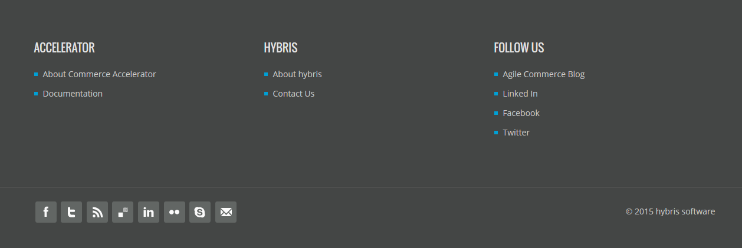

* To create a Template i.e. header and footer for the site copy the files from previous version or modify following files accordingly in **b2bassetsstorefront** extension:

1. master.tag file:

Copy complete master.tag file from previous version to new 5.7 version.

* You can add new CSS and JS related files into this file using <template:styleSheets/> & <template:javaScript/> tags respectively.

1. **Css.tag file:**

* To apply CSS changes, add all the entries of **.css** files from previous version to **css.tag** file of new b2bassetsstorefront extension.

1. **Js.tag file:**

* To apply Java Script changes, add all the entries of **.js** files from previous version to **js.tag** file of new b2bassetsstorefront extension.

1. page.tag file:

Copy complete page.tag file from previous version.

* Also copy below mentioned files from previous version to new version which are included in page.tag file:
* header.tag file.
* topNavigation.tag file.
* addToCart.tag file.
* footer.tag file.
* You may have to copy and merge the other tag files which are included in above tag files.
* Now, Copy all the **css** files existing at **path**: ../custom/b2bassets/b2bassetsstorefront/web/webroot/_ ui /desktop/common/css folder from previous version to new version at same path.
* Now, Copy all the **js** files existing at **path**: ../custom/b2bassets/b2bassetsstorefront/web/webroot/_ ui /desktop/common/js folder from previous version to new version at same path.

Changing Theme For B2BAssets

B2bassets uses a new theme named **theme-green** for its UI.

1. To apply this new theme to b2bassets copy **theme-green folder** from b2bassetsstorefront extension of previous version to this new setup.

At **path**: ../custom/b2bassets/b2bassetsstorefront/web/webroot/_ui/desktop/theme-green

* This theme-green folder contains CSS and JS folders which have all the .css and .js files mainly responsible for the site UI.
* **Theme-green.css** and **responsive.css** files from **theme-green** **folder** are one of the most important files which are mostly responsible for UI of the B2Bassets site pages.
* The theme-green.css file has CSS related to page content of the site and the responsive.css file has CSS related to responsiveness of the site pages (i.e. CSS responsible for Tablet and Mobile view).

1. Now create green theme via ImpEx for our site:

Go to **themes.impex** file of b2bassetscore extension and add theme green to it.

|  |
| --- |
| INSERT_UPDATE SiteTheme;code[unique=true]  ;green |

Also add entry of theme-green to **themes_en.impex** file:

|  |
| --- |
| UPDATE SiteTheme;code[unique=true];name[lang=$lang]  ;green;"Green" |

1. Assign the new theme to our site in **site.impex** file of b2bassetsinitialdata extension.

|  |
| --- |
| INSERT_UPDATE CMSSite;uid[unique=true];theme(code);channel(code);stores(uid);contentCatalogs(id);defaultCatalog(id);defaultLanguage(isoCode);urlPatterns;active;previewURL;startingPage(uid,$contentCV);urlEncodingAttributes;defaultPromotionGroup(Identifier)[default=powertoolsPromoGrp]  ;$siteUid;**green**;B2C;$storeUid;$contentCatalog;$productCatalog;$defaultLanguage;(?i)^https?://[^/]+(/[^?]*)?\?(.*\&)?(site=$siteUid)(|\&.*)$,(?i)^https?://$siteUid\.[^/]+(|/.*|\?.*)$;true;$storefrontContextRoot/?site=$siteUid;homepage;storefront,language,currency |

1. Now update running system from HAC to see the changes on site.

To Make Pages & Components Responsive:

To make sections and components of the page responsive define CSS for the components in responsive.css file of the theme-green folder.

Responsive.css file is mainly responsible for mobile, tab and desktop view of a site.

Modify Template Pages

1. Copy complete file from previous version or modify the template file used for the b2bassets **homepage** i.e. **landingLayout1Page.jsp**:

* Define page slots for the b2bassets homepage.
* Define Sections e.g. *Section2A, Section2B, Section3 etc.*
* Add CSS div tags and apply classes to the slots/sections for the page CSS.

**Do this for other page templates too if required to change the UI of the b2bassets site** .e.g. accountLayoutPage.jsp

Modify JSP & Tag Files

To migrate UI and to get same look and feel for the site, copy or merge JSPs & Tag files related to Content pages from previous version setup files to v5.7.

**Follow similar steps mentioned below to migrate UI of B2Bassets site.**

Example

My Account Page:

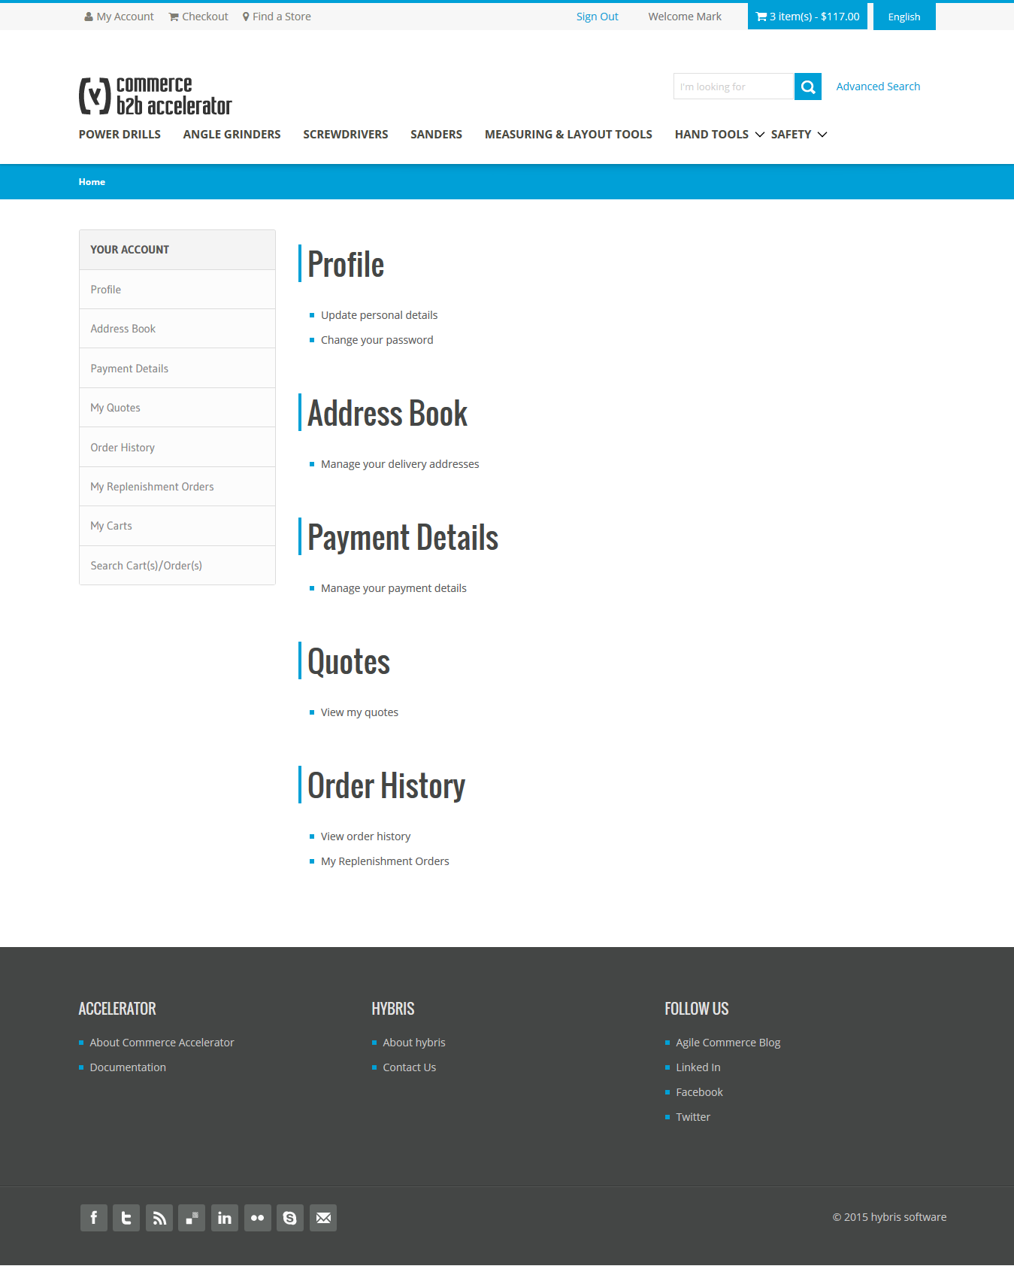

**For example, if you are modifying My Account pages of B2Bassets site follow the steps below:**

* Modify the Template file of **My Account** i.e. accountLayoutPage.jsp file as described in section 2.2 modify template pages
* Now, Modify Account Sidebar Component related JSP’s and tag files.

i.e. accountsidenavigationcollectioncomponent.jsp, accountnavigationcomponent.jsp

Copy or merge the above JSP files by copying Div tags and css classes from previous version JSPs to new.

**Account Sidebar Navigation:**

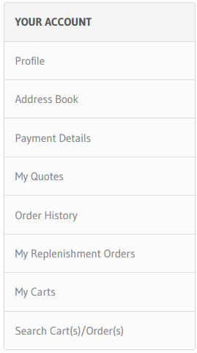

* Now, for the below view of My Account page modify all the JSP and tag files related to components used in My Account page:

E.g. **AccountProfileComponent-** accountProfilePage.jsp,

**AccountAddressBookComponent**-accountAddressBookPage.jsp,

**AccountPaymentDetailsComponent**- accountPaymentInfoPage.jsp,

**AccountMyQuotesComponent**- accountMyQuotesPage etc.

* Copy and merge all the other **JSP files** related to **My Account page** content, Copy & merge the **tag files** too, that are included in above JSPs.

|  |
| --- |
|  |

* While migrating copy the complete file from previous version or merge the JSP & Tag files by copying Div tags and CSS classes from JSPs of previous version to new.

(Note: Comment unnecessary or duplicate css code from .css files for proper UI of the pages)

1. B2BAssets Responsive UI Designs

B2BAssets Desktop View:

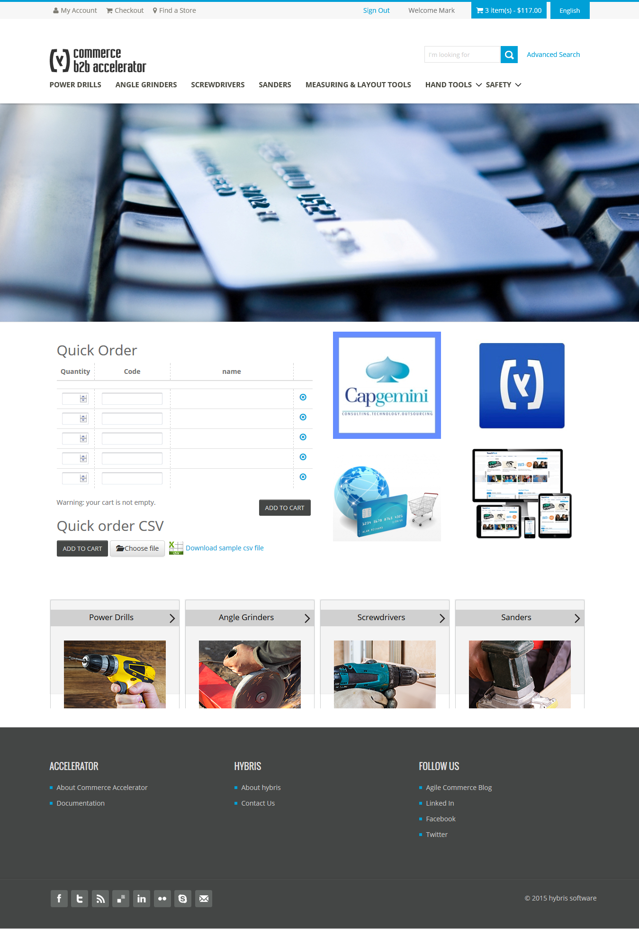

B2BAssets Tablet View:

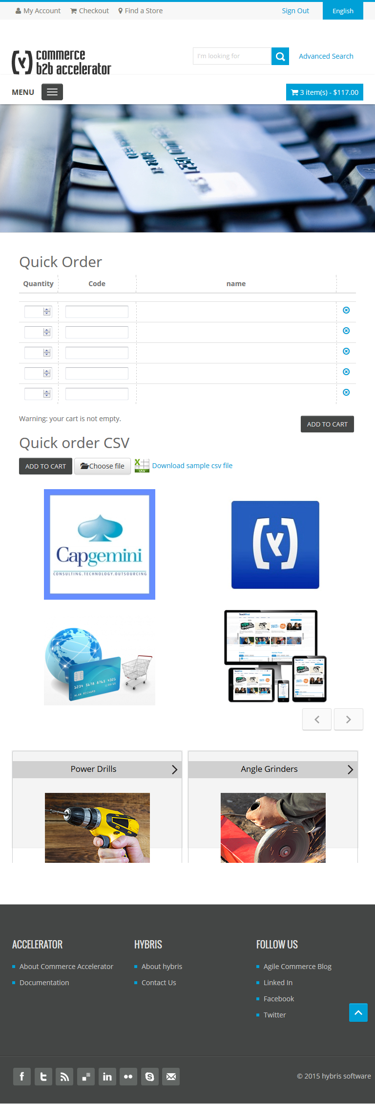

B2BAssets Mobile View:

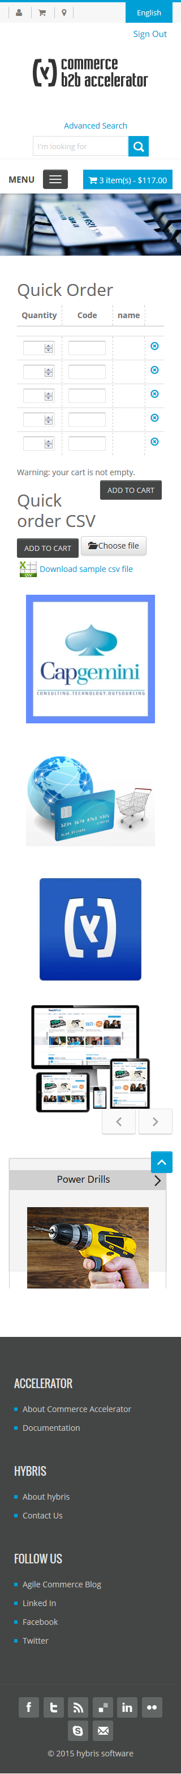

1. UI Changes In v5.7

Newly Applied UI Changes For B2BAssets v5.7

Home Page: Thumbnail position arranged properly for Tablet view

|  |  |
| --- | --- |
| **B2bassets Home page(Version 5.7)** | **B2bassets Home page (Previous Version)** |
| D:\B2bMigration\Home.png | D:\B2bMigration\Home185.png |

Login Page: Help banner image is present.

|  |  |
| --- | --- |
| **B2bassets Login Page (Version 5.7)** | **B2bassets Login Page (Previous Version)** |
| D:\B2bMigration\LoginPage.png | D:\B2bMigration\LoginPage185.png |

Replenishment Order Confirmation Page: Fixed UI with responsivness

|  |  |
| --- | --- |
| **B2bassets Replenishment Order Confirmation Page (Version 5.7)** | **B2bassets Replenishment Order Confirmation Page (Previous Version)** |
| D:\B2bMigration\RConfirmation.png | D:\B2bMigration\RConfirmation185.png |

Cart Page: Promotion, help banner image is not there.

|  |  |
| --- | --- |
| **B2bassets Cart Page (Version 5.7)** | **B2bassets Cart Page (Previous Version)** |
| D:\B2bMigration\CartPage.png | D:\B2bMigration\CartPage185.png |

My Account Page - B2B Customer: Content is dynamic in 5.7 version

|  |  |
| --- | --- |
| **B2bassets My Account Page - B2B Customer (Version 5.7)** | **B2bassets My Account Page - B2B Customer (Previous Version)** |
| D:\B2bMigration\My Account-Dynamic.png | D:\B2bMigration\My Account185.png |

My Replenishment Orders Page: UI fixed with responsiveness

|  |  |
| --- | --- |
| **B2bassets My Replenishment Orders Page (Version 5.7)** | **B2bassets My Replenishment Orders Page (Previous Version)** |
| D:\B2bMigration\My Replenishment Orders.png | D:\B2bMigration\My Replenishment Orders185.png |

My Replenishment Orders Details Page: Table on the page is not responsive in Mobile view

|  |  |
| --- | --- |
| **B2bassets My Replenishment Orders Details Page (Version 5.7)** | **B2bassets My Replenishment Orders Details Page (Previous Version)** |
| D:\B2bMigration\Replenishment Order Details.png | D:\B2bMigration\My Replenishment Details185.png |

Cancel Replenishment Orders Details Page: UI fixed with responsiveness

|  |  |
| --- | --- |
| **B2bassets Cancel Replenishment Orders Details Page (Version 5.7)** | **B2bassets Cancel Replenishment Orders Details Page (Previous Version)** |
| D:\B2bMigration\ReplenishmentCancel.png | D:\B2bMigration\ReplenishmentCancel185.png |

Search Carts/Orders Page: UI fixed with responsiveness

|  |  |
| --- | --- |
| **B2bassets Search Carts/Orders Page (Version 5.7)** | **B2bassets Search Carts/Orders Page (Previous Version)** |
| D:\B2bMigration\Search Cart and Order.png | D:\B2bMigration\searchCarts185.png |

Update Email Page: Cancel button added to page

|  |
| --- |
| **B2bassets Update Email Page (Previous Version)** |
| D:\B2bMigration\update185.JPG |
| **B2bassets Update Email Page (Version 5.7)** |
| D:\B2bMigration\update.JPG |

Order Approval Dashboard Page: UI fixed with responsiveness

|  |  |
| --- | --- |
| **B2bassets Order Approval Dashboard Page (Version 5.7)** | **B2bassets Order Approval Dashboard Page (Previous Version)** |
| D:\B2bMigration\OrderApprovalDashboard.png | D:\B2bMigration\OrderApprovalDashboard185.png |

Order Approval Details Page: UI fixed with responsiveness

|  |  |
| --- | --- |
| **B2bassets Order Approval Details Page (Version 5.7)** | B2bassets Order Approval Details Page (Previous Version) |
| D:\B2bMigration\OrderApprovalDetails.png | D:\B2bMigration\OrderApprovalDetails185.png |

My Company Page - Organization Management: Content is dynamic in 5.7 version

|  |  |
| --- | --- |
| B2bassets My Company Page (Version 5.7) | B2bassets My Company Page (Previous Version) |
| D:\B2bMigration\MyCompany.png | D:\B2bMigration\MyComp185.png |

Manage Budgets Page: Fixed Tablet View

|  |  |
| --- | --- |
| B2bassets Manage Budgets Page (Version 5.7) | B2bassets Manage Budgets Page (Previous Version) |
| D:\B2bMigration\manageBudgets.png | D:\B2bMigration\manageBudgets185.png |

Edit User for Unit - B2B Approver ManageUnitApproversListPage: Fixed Tablet View

|  |  |
| --- | --- |
| B2bassets Edit User for Unit - B2B Approver ManageUnitApproversListPage (Version 5.7) | B2bassets Edit User for Unit - B2B Approver ManageUnitApproversListPage (Previous Version) |
| D:\B2bMigration\manageUnitApprover.png | D:\B2bMigration\manageUnitApprover185.png |

Find Store near Me Page - Current Position Details - View Map: New page, UI fixed with responsiveness

|  |
| --- |
| B2bassets Find Store - Details Page (Version 5.7) |
| D:\B2bMigration\StoreFinder.png |

Enabled Advanced Search Link for Mobile & Tablet View

|  |
| --- |
| B2BAssets Mobile View v5.7 |
| D:\B2bMigration\AM.png |

|  |
| --- |
| B2BAssets Tablet View v5.7 |
| D:\B2bMigration\AT.png |

Resolved Extra Space Issue

In previous version some of the pages had extra space to the right, because of which the UI of the page was not proper. This issue was resolved by aligning the page components.

**Extra Space Issue Resolved for following pages:**

* + - 1. Product Details Page
      2. Multi Step Checkout Summary Page
      3. Order Confirmation Page
      4. My Quotes Page
      5. Order History Page
      6. My Replenishment Orders Page
      7. My Replenishment Orders Details Page
      8. My Carts Page
      9. Order Approval Details Page
      10. Manage Cost center Select budget page

Checkout UI Difference In v5.7

1. **Checkout Page before Version 5.7- Account Payment**

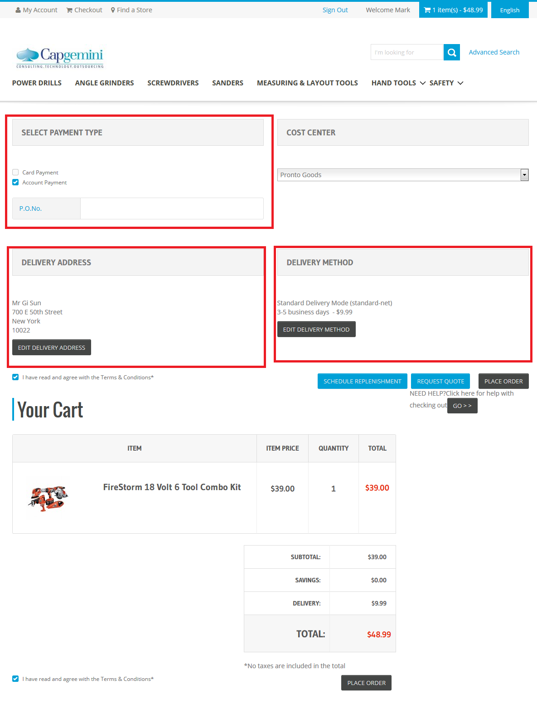

1. **Checkout Page before Version 5.7- Card Payment**

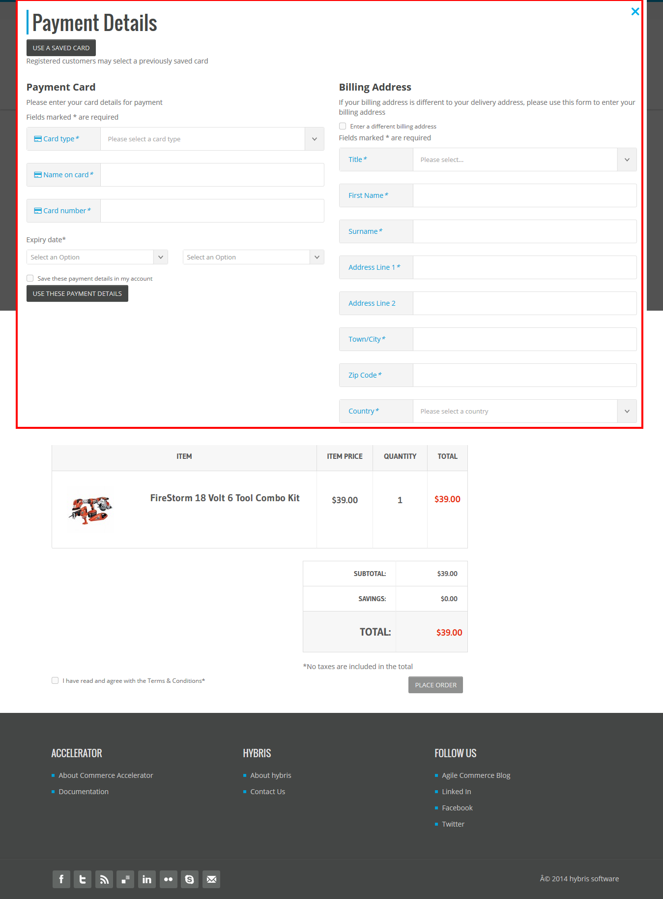

B2bassets Multi Step Checkout Pages (Version 5.7): Changed UI

**Step 1A**: Choose Payment Type – Account Payment

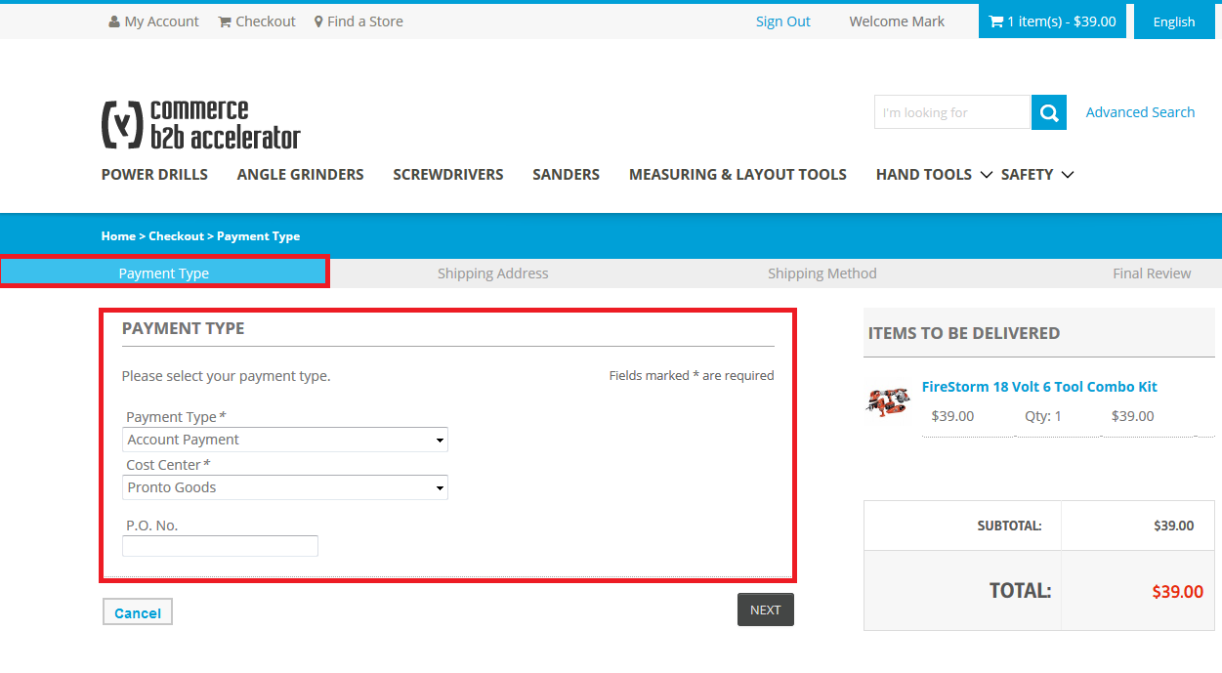

**Step 1B**: Choose Payment Type – Card Payment

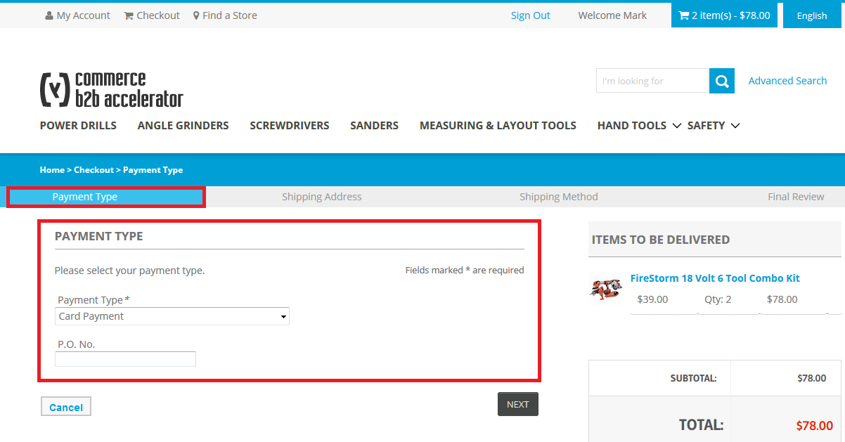

**Step 2**: Add Address Details

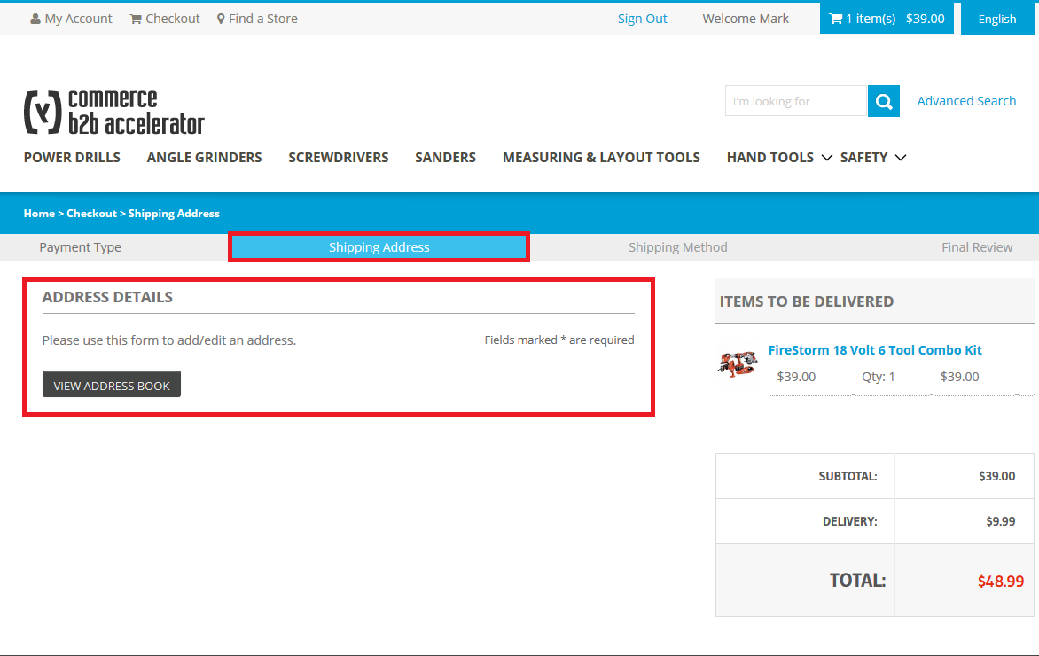

**Step 3**: Choose Shipping Method

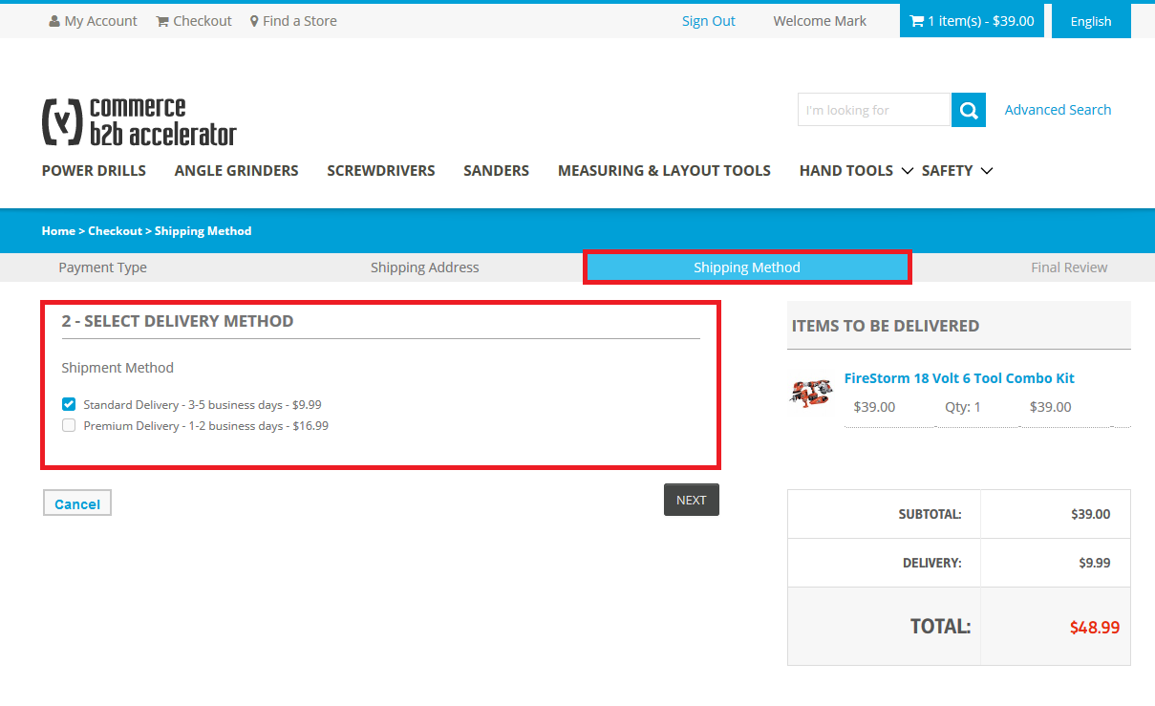

**Step 4**: Add Payment & Billing Address – Card Payment

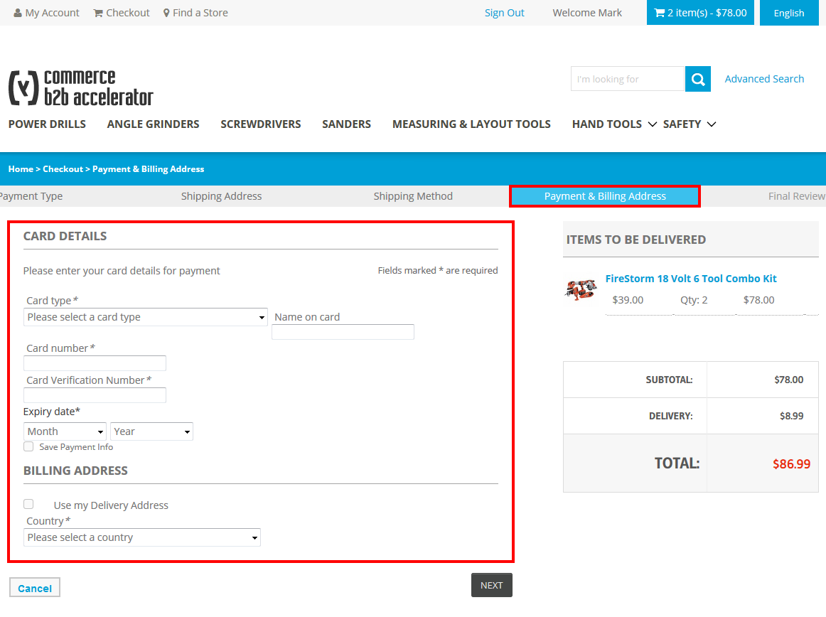

**Step 5**: Final Review Before Placing Order

